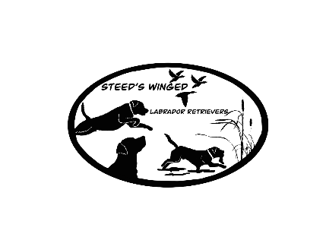
Steeds Winged Labrador Retrievers
130 S Happy TRL
Sulphur Rock, AR 72579
Autumn Steed 501.206.6394
Chase Steed 479.699.4846
HEALTH GUARANTEE:
1) The breeder guarantees this puppy is bred within AKC/UKC breed standard. The breeder guarantees the puppy to be in good health at the time of purchase, to the best of their knowledge. Buyer has examined puppy and agrees the puppy to be in good health. The breeder also guarantees that the puppy has had core vaccinations and scheduled de-worming’s appropriate to the puppy’s age. (All puppies have been examined by our local vet and come with a health certificate attached in puppy packet.)
2) It is recommended that the buyer have the puppy examined by a licensed veterinarian (at buyers expense) within 5 days AFTER receiving the puppy. IF THE PUPPY IS NOT EXAMINED WITHIN 5 DAYS AFTER PURCHASE, THIS GUARANTEE WILL BE NULL AND VOID. If at the time of examination, the veterinarian finds the puppy to have a life-threatening genetic defect, the puppy must be returned to the breeder (at buyers expense), with a written report from the veterinarian, and all paperwork given to you at the time of purchase to replace puppy with a puppy of same value. If in the result that the puppy dies from a life-threatening genetic disease and requests another puppy, an autopsy report must be obtained (at buyers expense) to receive a new puppy. Buyer understands that there may be a wait for another puppy of comparable breeding and price to become available. This guarantee does NOT cover cosmetic defects (improper bites, hernias, ect.) Any puppy found to not be receiving proper care or being neglected at any time, MUST be returned to the breeder at buyers expense. NO CASH REFUNDS.
3) If the puppy dies within the first 5 days within being in possession of the buyer, buyer must have autopsy performed to prove cause of death in order to receive a replacement puppy of equal value when one becomes available. Breeder has the right to have their own vet confirm any findings in said report.
4) Breeder will NOT guarantee against common problems such as hypoglycemia, internal or external parasites, coccidia, giardia, or diarrhea due to stress from shipping, new home, or diet. Note: Urinary Tract Infections (UTI) can also be a common issue with this breed during puppyhood. Buyer will assume full responsibility for health, temperament, and appearance of the above puppy described, upon possession. It is the buyers responsibility to protect puppy from dangerous and infectious situations until the puppy has completed its series of vaccinations.
5) If your veterinarian states that your puppy has any problem that makes it a poor health risk (this does not include the above stated external parasites such as fleas, ticks, lice, mites, mange, etc. or internal parasites such as roundworms, whipworms, hookworms, tapeworms, giardia, coccidia, etc), you may, within 5 days of purchase, return the puppy (along with all AKC registration papers and materials) for a full refund. A written, signed, and dated statement from your veterinarian is required detailing description of symptoms supporting his/her opinion and an explanation as to why thus puppy would be a poor health risk. The exam and all associated costs are the buyer’s responsibly. Please note that this is 5 days from when the puppy leaves our premises.
6) Seller will provide a 26 month guarantee on OFA hips (guarantee to score fair or better), OFA Eyes, and OFA cardiac clearance. Breeder will not cover elbows due to the extreme fragile nature. Elbows are severely impacted by the puppies/dogs environment. If you are looking to get full registration we suggest you take xrays every 6months beginning at 6 months of age to prove there was any injury related to the failure of one or both elbows. Puppy/Dog must pass all the health certifications, including elbows to have full registration granted. Full registration must be discussed ahead of time and agreed upon. If this puppy fails any of these OFA certification excluding elbows the dog must be returned to SWLR, we will have our vet retake images, or re run test as necessary(at buyers expense). If results are still failing SWLR will keep the dog, and will replace it with a puppy of equal value from current or upcoming litter. If owner wishes to keep the dog they will be refunded 25% of purchase price.
____________
____________
Buyer(s) Initials

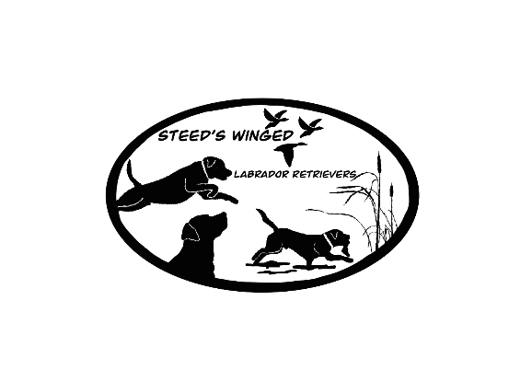
Steeds Winged Labrador Retrievers
130 S Happy TRL
Sulphur Rock, AR 72579
Autumn Steed 501.206.6394
Chase Steed 479.699.4846
CONDITIONS FOR SWLR DOGS GUARANTEE:
To make a claim under any of the provisions, all documentation from veterinarians must be submitted for review. In order for this guarantee to be honored, buyer must abide by the following rules:
• Should the dog identified in this contract ever be offered for sale, given away, or otherwise need placement, Steeds Winged Labrador Retrievers has the Right of First Refusal. If SWLR does not purchase or rehome this puppy, the owner outlined in this contract is responsible for providing the information of the new owner of puppy/dog within 30 days of the puppy/dogs placement.
• All request and refunds must be submitted in writing within 10 days after receiving your puppy’s written diagnosis.
• If you are eligible to receive a refund, you must return the dog and registration papers that transferable back to Steeds Winged Labrador Retrievers before a refund will be issued. This copy of the guarantee must accompany the dog along with the buyers bill of sale. Buyer is responsible for any shipping costs to return the dog back to Steeds Winged Labrador Retrievers or the fee will be deducted from the refund amount.
• You will receive a 25% refund if you choose to keep the dog after failing genetic testing. In this situation, you must spay/neuter the dog at your expense and submit written verification from the licensed veterinarian who performed the procedure before we will issue your refund. You will also need to send us copy of this guarantee along with the owner’s copy of the bill of sale.
• If you choose to receive a new puppy instead of a refund, the puppy will be of comparable breeding and price. If buyer chooses to receive a puppy of higher breeding and price, the price of the dog covered by this guarantee will apply toward the higher price of the new puppy. You may choose to keep your dog. In this situation, you must spay/neuter the dog at your expense and submit written verification from the licensed veterinarian who performed the procedure before we will allow you to receive the replacement puppy. You will also need to send us copy of this guarantee along with the owner’s copy of the bill of sale.
• Owner must not spay/ neuter dog until minimum age of 18 months of age to allow growth plates to mature. Complete health records must be submitted to Steeds Winged Labrador Retrievers along with any other veterinary documentation. Poor health management may disqualify you from receiving a new puppy or a full or partial refund.
• If full rights are granted, The dog must not be used for breeding until he/she reaches the age of 24 months in which they are fully matured, along with having all health testing including pawprint genetic or Embark panel, OFA hips scoring fair or better, OFA elbows scoring normal, OFA eyes scoring clear/normal as well as OFA cardiac clearances scoring normal/clear. The dog must also have at least one title. If he/she sires or whelps a litter before 24 months of age, this guarantee is void and you will be charged a fee of 2x the purchase price amount of said dog.
• The owner must be the original owner. This guarantee is non-transferable to new owners if the dog is sold.
• The dog CANNOT be bred to a dilute (silver, charcoal, and/or champagne) or poodle/ doodle/ non- pure bred Labrador retriever for any reason. If bred to a dilute positive dog or any dog carrying any dilute lines in the pedigree, or non-Labrador retriever dog the owner is responsible for 5 times the amount of purchase price!!!!
• Your refund, if applicable, will be issued within 90 days.
By signing this document, I understand and accept the terms and conditions of Steeds Winged Labrador Retrievers Guarantee.
_______________________________ __________________________
_______________________________ __________________________
Breeder(s) signature Date
_______________________________ _________________________
_______________________________ _________________________
Buyer(s) signature Date

