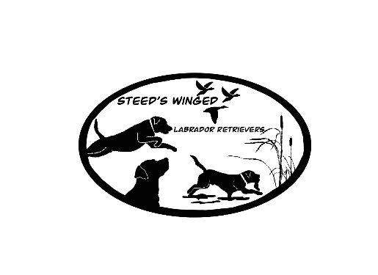
Steeds Winged Labrador Retrievers
130 S Happy TRL
Sulphur Rock, AR 72579
Autumn Steed 501.206.6394
Chase Steed 479.699.4846
BILL OF SALE AND CONTRACT:
Breed:__________________________________ Sex:_____________________________
DOB:______________________ Markings (if any) : ________________________________
Color:__________________________ AKC#:____________________________________
Microchip #:_________________________________Collar color:______________________
Sire:________________________________ Dam:___________________________________
Limited purchase price: $_________________
Remaining balance: $__________________ Deposit of $500 paid on : _________________
Date of pickup________________ Tax Rate:__6.5%____Tax amount: $_________________
Shipping cost (if any): $_____________________ (This includes vet check, crate, and ticket.)
Buyer’s intentions for this puppy include:
Pet/Companion______ Hunting_______ Field Trial and/or Hunt Tests_______Confirmation_______
Pet Therapy/Service Dog______ Breeding______ Detection_________
Full Reg:___________ or Limited Reg:__________
Deposits are non-refundable but may be transferred to different litter. The seller, SWLR will provide a 26 month Health Genetic, hip, eye, and cardiac Guarantee at the time of sale. Seller makes no guarantee on physical characteristics of these puppies. Puppies come with first round of core vaccinations, de-wormed, microchipped, heartworm prevention, puppy starter pack, and UKC and/or AKC Registration.
***PLEASE VIEW ATTACHED HEALTH GUARANTEE FOR MORE DETAILS***
Puppies will only be held past the date of eight (8) weeks of age by prior arrangement. Seller may sell any puppy held past the date of nine (9) weeks of age (unless prior arrangement has been made) with buyer forfeiting Deposit and all claims to the puppy. If puppy has been paid in full, seller will return the purchase price, minus the deposit. Any expenses incurred by the seller shall be deducted from any returned monies owed to buyer.
By completing this document you are agreeing to the following:
• The purchase of the above stated puppy
• To pay the balance in FULL when picking up your puppy if you have not already done so
• To pick up your puppy no later than one week after the date stating when puppy is ready to go home, unless other arrangements are agreed upon.
What you can expect to receive by completing this document:
• A healthy AKC/UKC registered Labrador retriever puppy
• Bill of sale, 26 month Health Guarantee, Puppy folder containing all necessary documents and vaccine records, as well as puppy pack.
• AKC/UKC Registration with Limited registration rights. Buyer purchases limited registration, he or she understands that the purchased dog cannot have any registerable litters of puppies or have showing rights. Full registration can be lifted to approved breeders once proof of all health clearances are provided. Including pawprint or Embark genetic panel, OFA hip(scoring fair or better), OFA elbow(scoring normal), OFA eye(clear), OFA cardiac clearance(clear). Along with proof of some form of title, this can be in any venue of owners choosing.
***Steeds Winged Labrador Retrievers is a Dilute-Free breeder*** By signing this contract, I understand and agree to not allow this puppy to breed to any dilute or dilute carrier dogs. (SILVER, CHARCOAL, OR CHAMPAGNE). The same terms apply to breeding said puppy to any poodles, doodles, or any non-Labrador retriever breed. If I violate this portion of the contract, I understand that I will be held responsible for 5 times the original purchase price of the puppy.
The buyer has read, understands, and agrees to the terms of the above stated contract with “Steeds Winged Labrador Retrievers”.
_______________________________ __________________________
_______________________________ __________________________
Breeder(s) signature Date
_______________________________ __________________________
_______________________________ _________________________
Buyer(s) signature Date

